|  |  |
| --- | --- |
| C:\Users\Amadou Barrow\Desktop\WebImages\ygap_logo_1.jpg | **WE HAVE A PROBLEM PROJECT ANALYSIS** |
| Project Name: We Have A Problem |
| Date: June 21th, 2012 |
| Preparer: Amadou Barrow |

THE “WE HAVE A PROBLEM” PROJECT OVERVIEW

The “We Have a Problem Project” is a highly challenging project that has been guaranteed by our project engineers last year, but they failed to deliver the final deliverable at the expected time. The 3-month status report indicated the project was on track both financially and schedule.

Nine months into the project with all funds been the expended, the engineers failed to deliver the project and begging for an extra 6-month to complete the project. They guaranteed again to deliver the final product to the customer in six months. Accounting indicates that the extra 6-months will cost them an extra $600k. Also, at the ninth month, the customer was on the phone asking for the finished product. Hence, they were “guaranteed” for the final deliverable at that time.

1. ANALYSIS OF THE PROJECT

Given that the 3-month status report was right on track, from both accounting and engineer’s perspective (report). The project went of schedule in the next 6-months, while all the budgeted money has been used. What went wrong?

* Since the engineers claimed that the 3-month’s report was right on track, there is possibility that there was no report at 6-months into the project.
* There’s a possibility that the money has been missed used.
* The engineers might have under estimated the schedule

1. THE EARNED VALUE ANALYSIS

To better analysis the project, a graphical presentation will be used to show the EV, PV, and AC at differing points or months into the project. These values will be used to recommend a suitable plan to for the project and to justify the recommendations too.

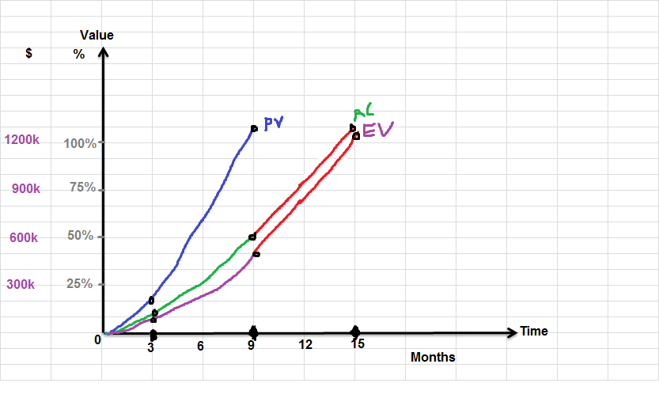

Based on the information given, one can assume that the total allocated money for the project was $1200K, given the fact that the extra 6-months requested will cost an extra $600K. I will be using $1200K as my budget throughtout the project.

1. RECOMMENDATION
2. A justifiable recommendation cannot be given without showing your recommendations in monetary terms. Here are the metrics used in showing the monetary at the 3-months and 9-months into the project.

* 3-months Status Report
* Schedule Variance (SV) = EV – PV

-$110K = $100K – $210K

* Cost Variance (CV) = EV- AC

-$10K = $110K - $120K

* Schedule Performance Index (SPI) = EV / PV

0.52 = $110K /210K

* Cost Performance Index (CPI) = EV / AV

0.92 = $110K / $120K

* 9-months Status Report
* Schedule Variance (SV) = EV – PV

-$1,150K = $50K - $1200K

* Cost Variance (CV) = EV- AC

-$10K = $50K - $60K

* Schedule Performance Index (SPI) = EV / PV

0.042 = $50K / $1200K

* Cost Performance Index (CPI) = EV / AV

0.83 = $50K / $60K

The “We Have A Problem” Project, was scheduled to be delivered within 9-months. At the ninth month, the project seems to have backdated to the third month. Hence, the 3-month report indicated that the project is right on track, so why would the project engineers need an extra 6-months to complete the project?

1. It sound like a cliché that the engineers are requesting for an extra 6-months because they haven’t done anything to the project since they gave the 3-month status report. If there is no work done, obviously the project will not be delivered.

To successfully deliver the product within 12 months, the schedule has to be condensed which will high impact on the project financially, but the benefits worth it. Because it will ensure that the project is delivered within 12-months.

* The engineering team needs to be shuffle
* The completed sub-project will be reviewed and continue on the positive ones and discontinue the failed sub-projects.
* Hire consultants to assist with the project

|  |  |
| --- | --- |
| **Recommendations** | **New Cost** |
| Hire Consultant | $12K per month = $36K |
| Condense Schedule by 3-months | $800K |
| **New Budget** | **$812K** |

Since, the customer is asking for the product now and the engineers are asking for extra 6-months, in order to make the customer happy the project needs to be delivered in three months. The followings are the recommendations and improvements for completing the project in 3 months (making it 12 months):

* More Time: Will negotiate with the customer to extend the time.
* Communication: A constant line of communication will be opened between the engineers, project managers, accountants and all other relevant stakeholders.
* Pressing the budget tight: Since the project funds has been expended with the project still far from fetch. The budget needs to be constantly monitored to avoid unnecessary expenditures.
* Checking/ Reviewing: Milestones or checkpoints will be reviewed or monitored constantly against the reports.

THE COMPANY

From the little information given about the project it seems that company has absolutely no way of controlling projects. There seem to be no line of communication between the stakeholders involved in the project, especially the project leaders / team, engineers and accountants.

Firing should not be an option at this time, since the whole project is far from reach. Therefore, all the efforts should be put into reviewing the variances and make up for the difference within 3-months. Firing or reprimanding can be discussed at the end of project.

FUTURE IMPROVEMENTS

To successfully implement future projects, the company needs to have the followings:

* Constant line of communication between the stakeholders
* Avoid guaranteeing unattainable schedules
* Monitor PV, EV and AV at every milestones and demand reports every month.
* Conduct site visits bi-monthly
* Avoid implementing unfamiliar technologies in their project (or hire consultant to assist them.